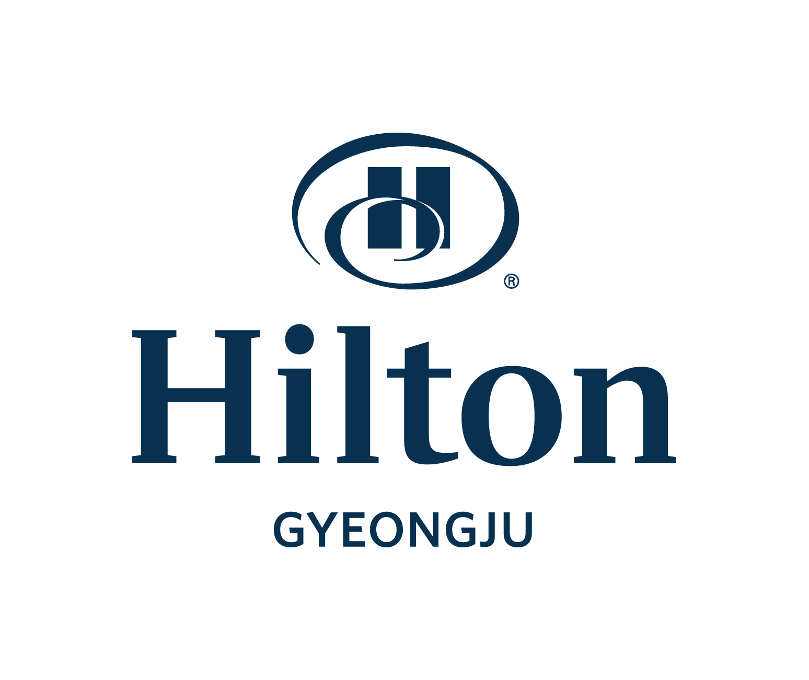
Hotel Reservation Form
33rd WIN GLOBAL ANNUAL CONFERENCE

*Please complete this form with all requested information and send it to the hotel directly by e-mail or fax.
E-mail: donghyo.seo@hilton.com/Reservation Manager Fax: +82-54-745-7799, Phone: +82-54-740-1232~4
*Please check-out reservation number after sending reservation form.

Participant Information
First Name: Last Name: Title: □Mr. □Ms.
Company Name: Position:
Sharing Room with First Name (Optional): Last Name:
Phone: Fax: E-mail:
Arrival Date: Departure Date: No. of Nights:
Special request and comments:

Accommodation Information (30th, March to 4rd, April. 2026)
Room Type | Rate | Day | Remark
■Deluxe Single(Double or Twin) | □ KRW 270,000 | Sun~Thu | Included 1 Person Breakfast
■Deluxe Single(Double or Twin) | □ KRW 300,000 | Fri | Included 1 Person Breakfast
■Deluxe Single(Double or Twin) | □ KRW 450,000 | Sat | Included 1 Person Breakfast
* 10% tax is included on the above rate.
* No later than 10th, Mar. 2026 to ensure room availability and group rate.
* Check-in time: 15:00 PM, Check-out time: 11:00 AM
* If not advance enrollments, breakfast should be available at KRW50,000

Payment Information
In order to guarantee your reservation, your credit card information must be accompanied.
□ AMEX □ VISA □ Master □ Dinners □ JCB □ Other( )
Card No.: Expiration Date(mm/yy)
Cardholder’s Name: im Date: Signature:

Cancellation Policy
- If you wish to cancel, please do so 5days prior to arrival to avoid cancellation penalties

♦ Confirmation from Hilton Gyeongju.
A reservation confirmation will be sent to you via email within 24 hours after your reservation is received.

